Dale Electric | Open Type Diesel Generator Set | 110 kVA ESP | Year of Manufacture 1972

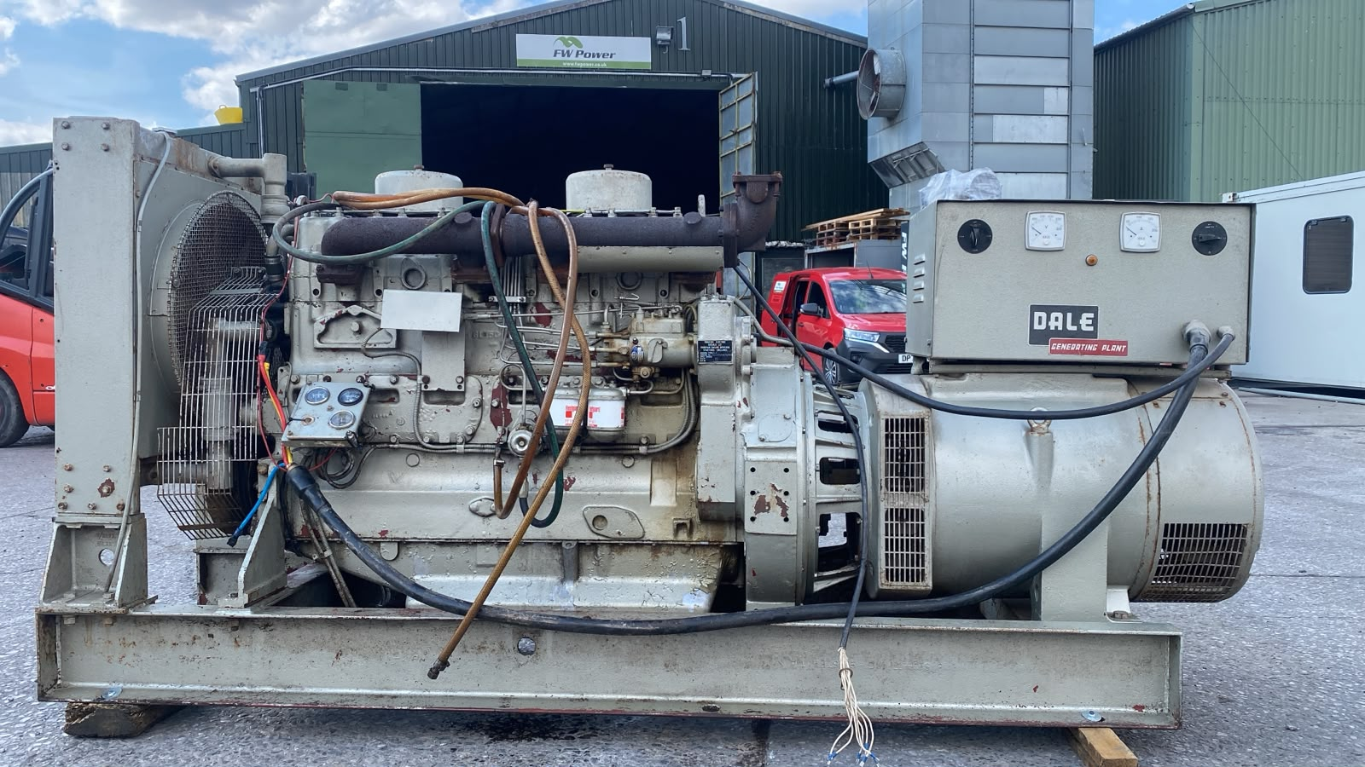
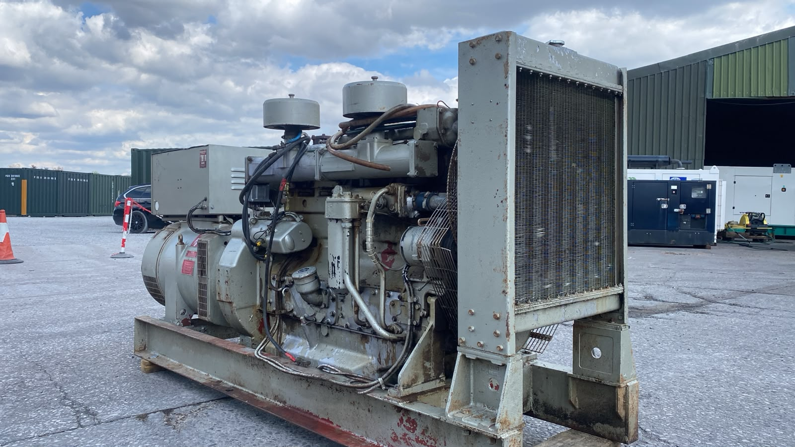
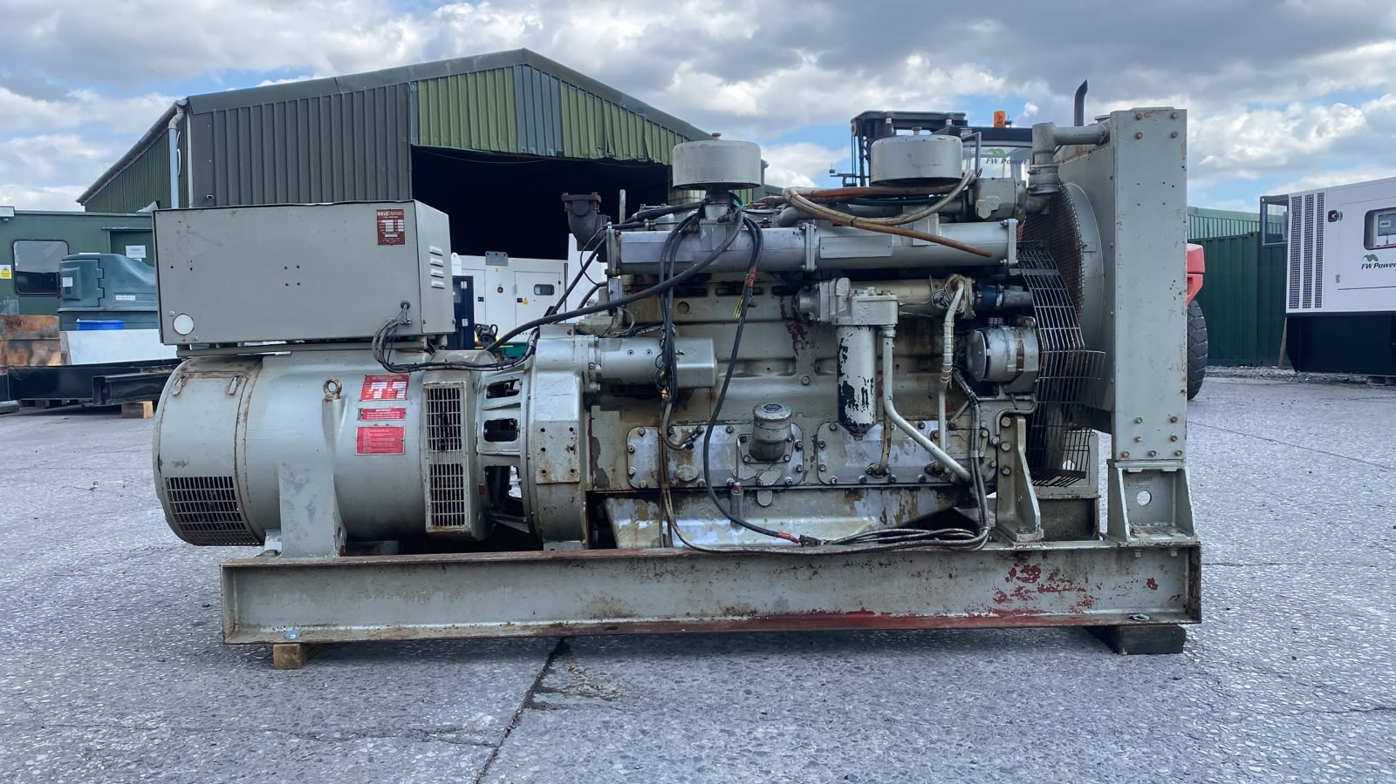

General Information
Low hours 110 kVA 100 kVA PRP Dale diesel generator set built on skids
Our Ref: FWP697


Key Specifications:
Engine: Dale
Dimensions:
- Length: TBC mm
- Width: TBC mm
- Hight: TBC mm
- Weight: TBC kg
- Fuel Tank: N/A

Alternator: Dale
Frequency: 50 Hz
Speed: 1500 RPM
Voltage: 400/230V
Power: 100 kVA /88 kW | 153 Amps
Year: 1972
Hours: TBC
Canopy Type: Open
Control Panel: Analog

Control & Distribution:
This is a vintage used industrial generator in unrestored condition. It shows age-related wear, paint deterioration and areas of surface corrosion, as clearly shown in the photographs.

Highlights:
• Low hours (Fully 75 point checked and approved)
• Good Condition
• Ready for immediate deployment

MORE PHOTOS BELOW

